## Implementation

### Task1

First task was to fill in the code of sampleAndSwap to get the partner to swap colors with using the handshake procesure. Then the findPartner was made to find the best partner to swap with using a particular function which sorted out to best partner for the node’s neighbors or a random sample

### Task2

In the first part of task2, simulating annealing was introduces where saCoolDown was modified to exponentially decrease the temperature while also modify findPartner with the help of the function acceptanceProb to understand if the node should be or not the best partner.

In the second part, a restart function was introduced when their where no more swaps to be done according to the algorithm. If that was the case, the T value was updated to its initial value to then proceed to make more swaps.

### Bonus

Added a variable restart where every time the minimum edgecut is made the restart = restart*1.1. The restart variable is then computed T = T*delta*restart. The argument for this is when a minimum is almost reached there is no longer any need for a temperature T as a random factor. Rather, you want the algorithm to converge to that minimum

## Result

Summary:

The pictures are in the following order: 3elt, add20, twitter. The converge was somewhat fast for Twitter but the others it wasn’t clear.

### Task1

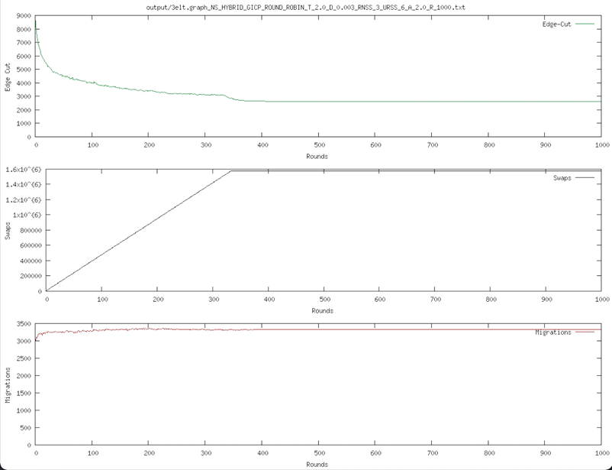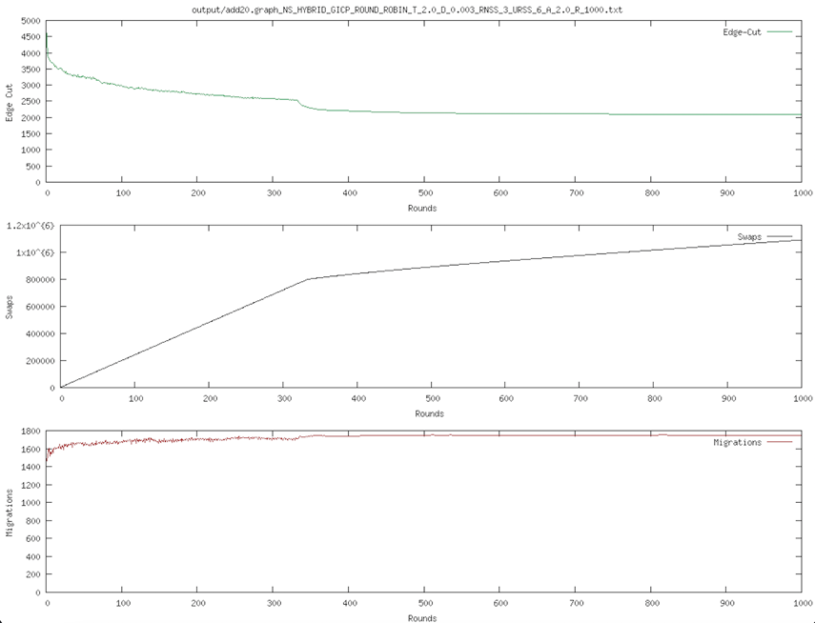

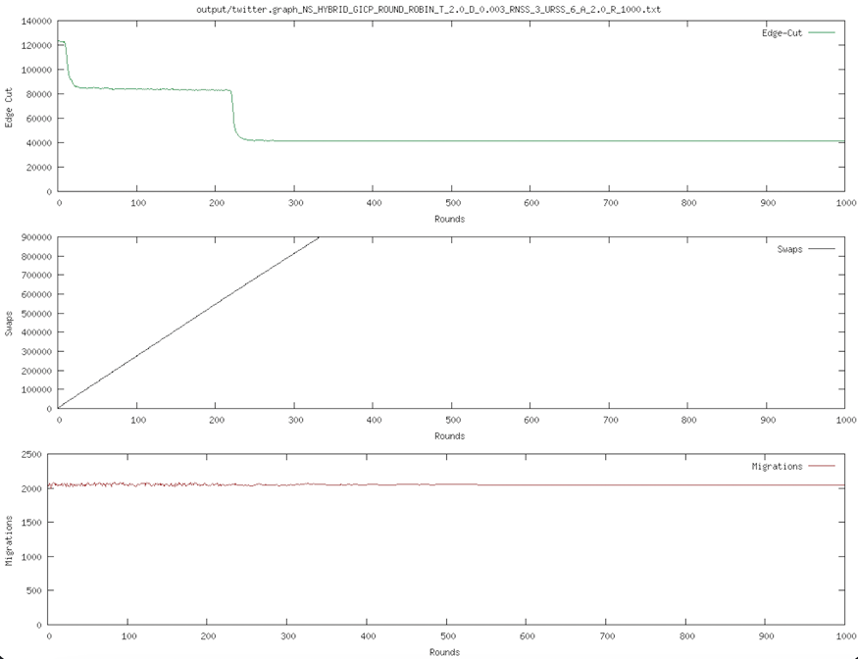

|  |  |  |  |  |
| --- | --- | --- | --- | --- |
| Graph | Edge cut | Swaps | Migrations | Convergence |
| 3elt | 2604 | 1580209 | 3328 | 460 |
| 20add | 2095 | 1090263 | 1751 | 1000 |
| Twitter | 41156 | 899515 | 2049 | 352 |

### Task 2

Summary:

When implementation simulated annealing, the result became vastly better with much smaller edgecuts. Likewise the convergence was better as well.

Part 1

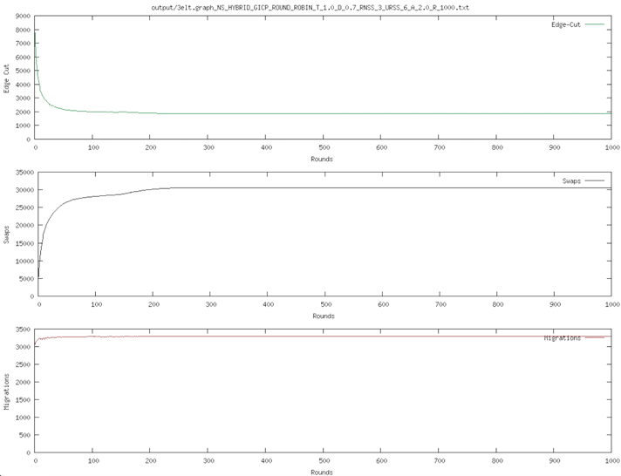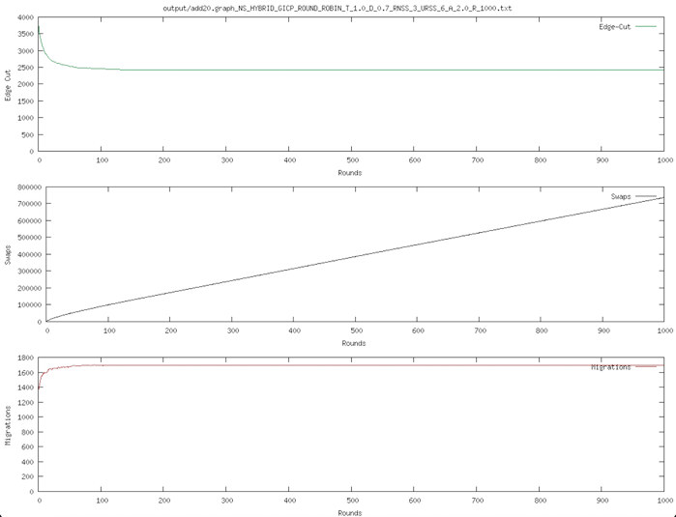

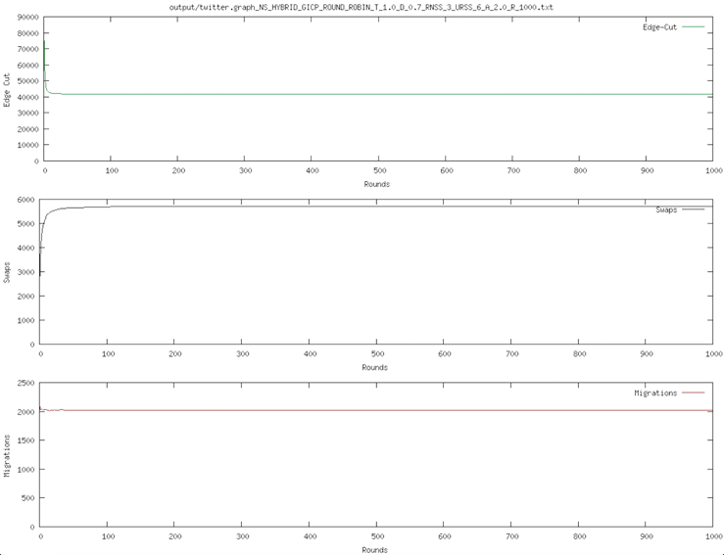

|  |  |  |  |  |
| --- | --- | --- | --- | --- |
| Graph | Edge cut | Swaps | Migrations | Convergence |
| 3elt | 1868 | 30461 | 3288 | 232 |
| 20add | 2414 | 736121 | 1697 | 149 |
| Twitter | 41782 | 5690 | 2020 | 102 |

Part 2

Summary: It was more difficult to understand where the convergence happened as the T value was introduced when convergence happened. However, it resulted in lower edge cut for 3elt and 20add which was promising.

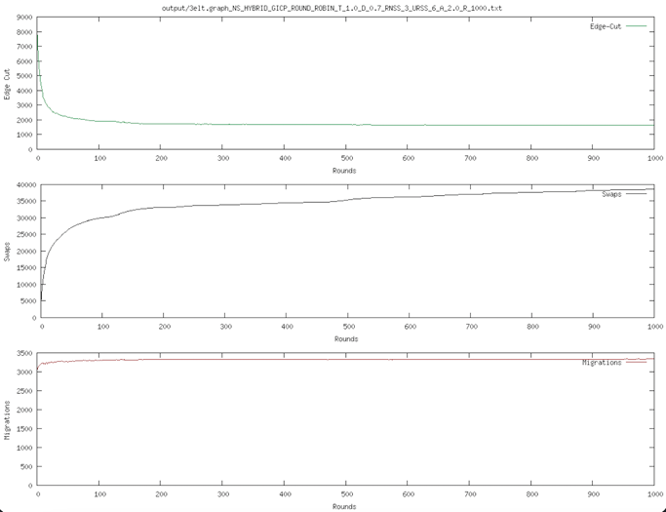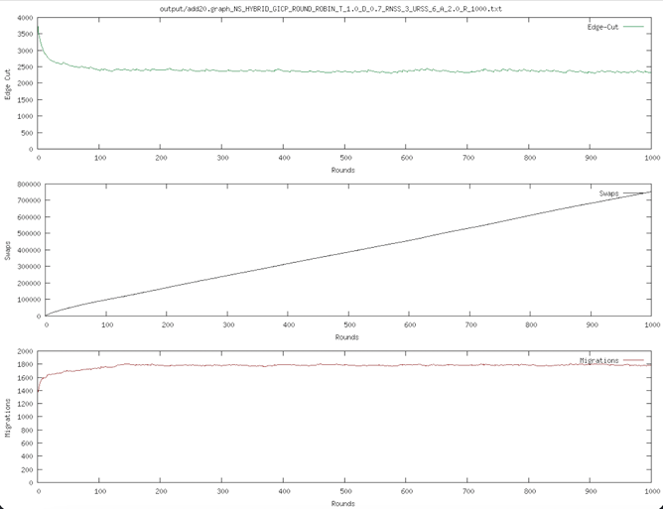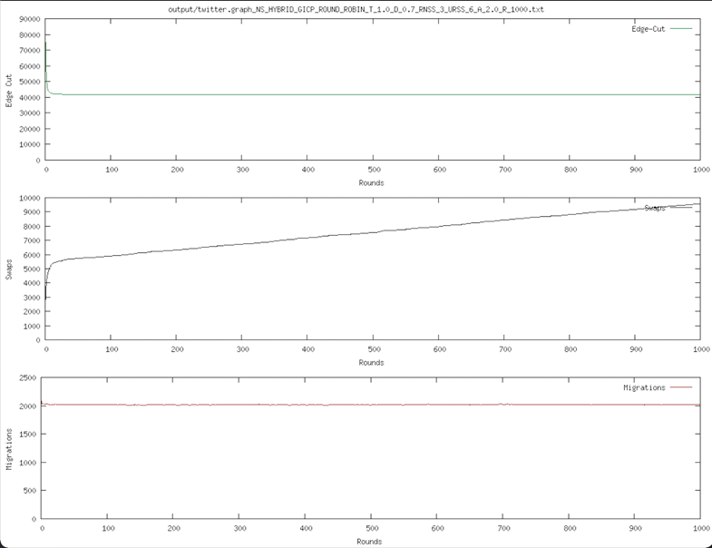

|  |  |  |  |  |
| --- | --- | --- | --- | --- |
| Graph | Edge cut | Swaps | Migrations | Convergence |
| 3elt | 1633 | 38612 | 3340 | Ca 232 |
| 20add | 2330 | 752195 | 1780 | 999 |
| Twitter | 41782 | 9563 | 2020 | Ca 102 |

Bonus Part

Summar: Here, the new introduced variable restarts made improvements on all three graphs as shown below compared to the other methods. As it also should be stated that simulating annealing and restart of T also was done in this part. With fast convergence but a slow improvement to find the optimal solution.

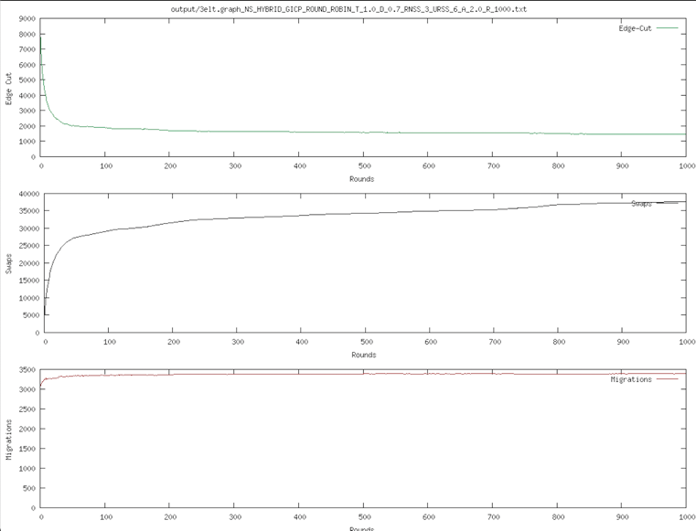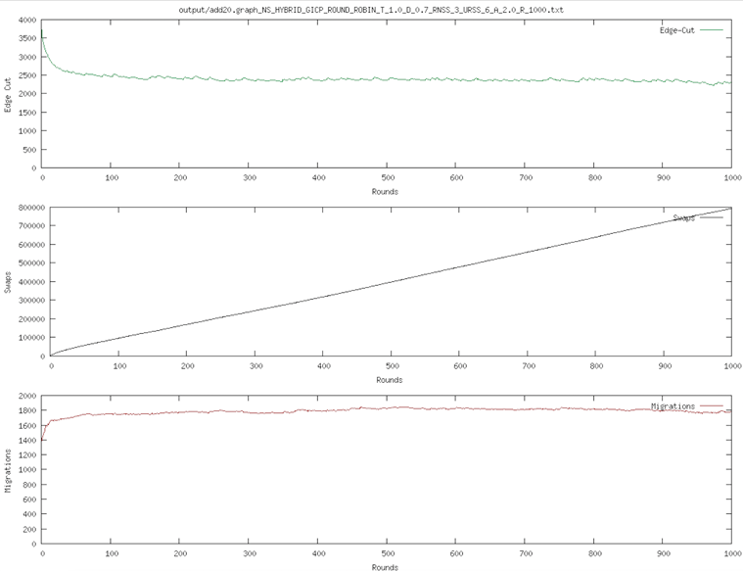

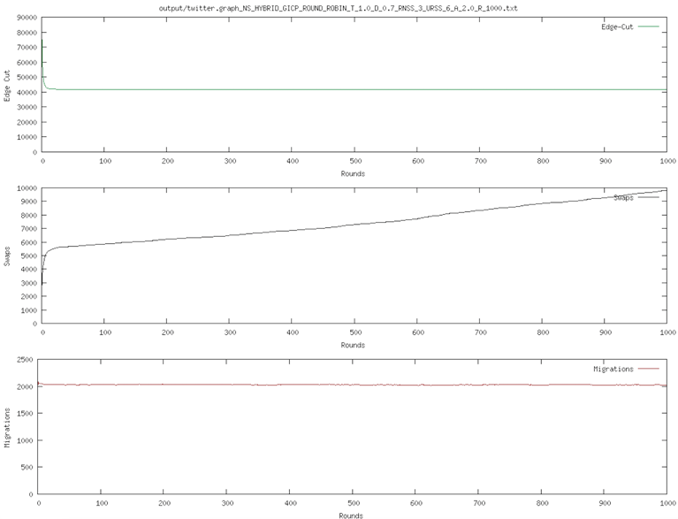

|  |  |  |  |  |
| --- | --- | --- | --- | --- |
| Graph | Edge cut | Swaps | Migrations | Convergence |
| 3elt | 1467 | 37631 | 3393 | 50 |
| 20add | 2293 | 792307 | 1773 | 100 |
| Twitter | 41729 | 8803 | 2016 | 30 |